Keenovo Silicone Heat Pad
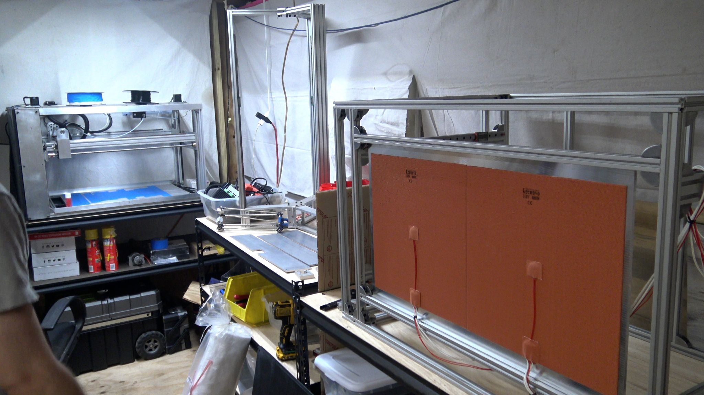

Related Content
3D Distributed
3D Printers
WorkHorse 3D Printer
WorkHorse 3D Printer BOM
Build Plate
Heated Bed
Ceramic Fibre
Keenovo Silicone Heat Pad
Build Plate
Build Plate Options

